Program 9: Create S3 Bucket and assign a custom policy

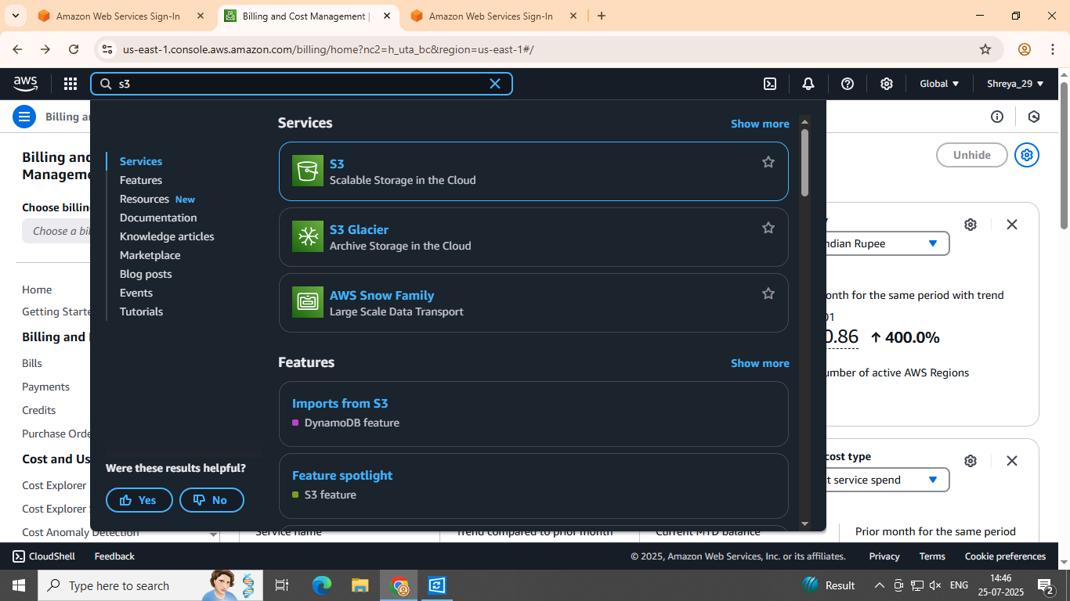 Step 1: Sign in to your AWS account and select "S3" from the list of services.

S

Step 2: Click on "Create bucket".

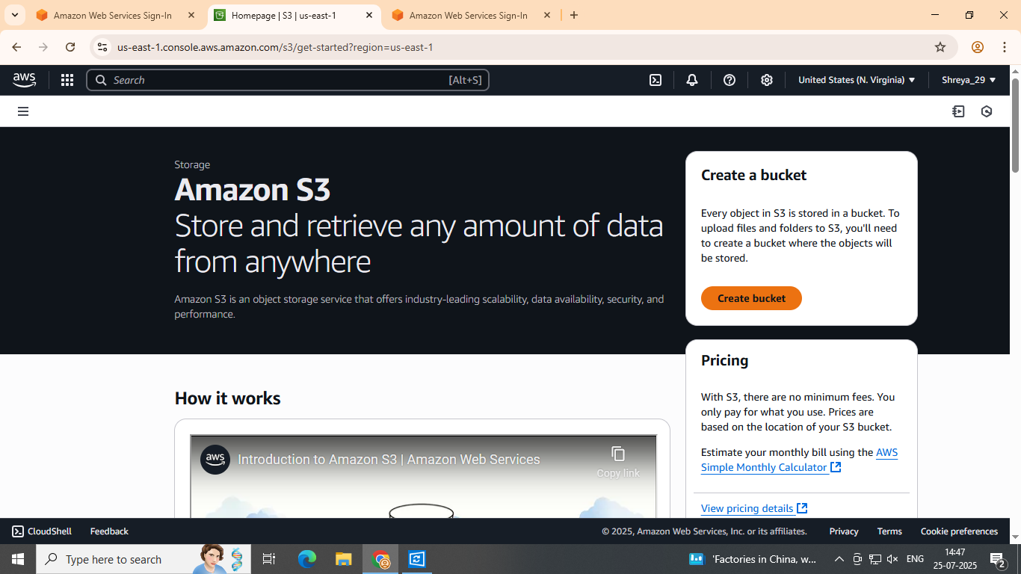

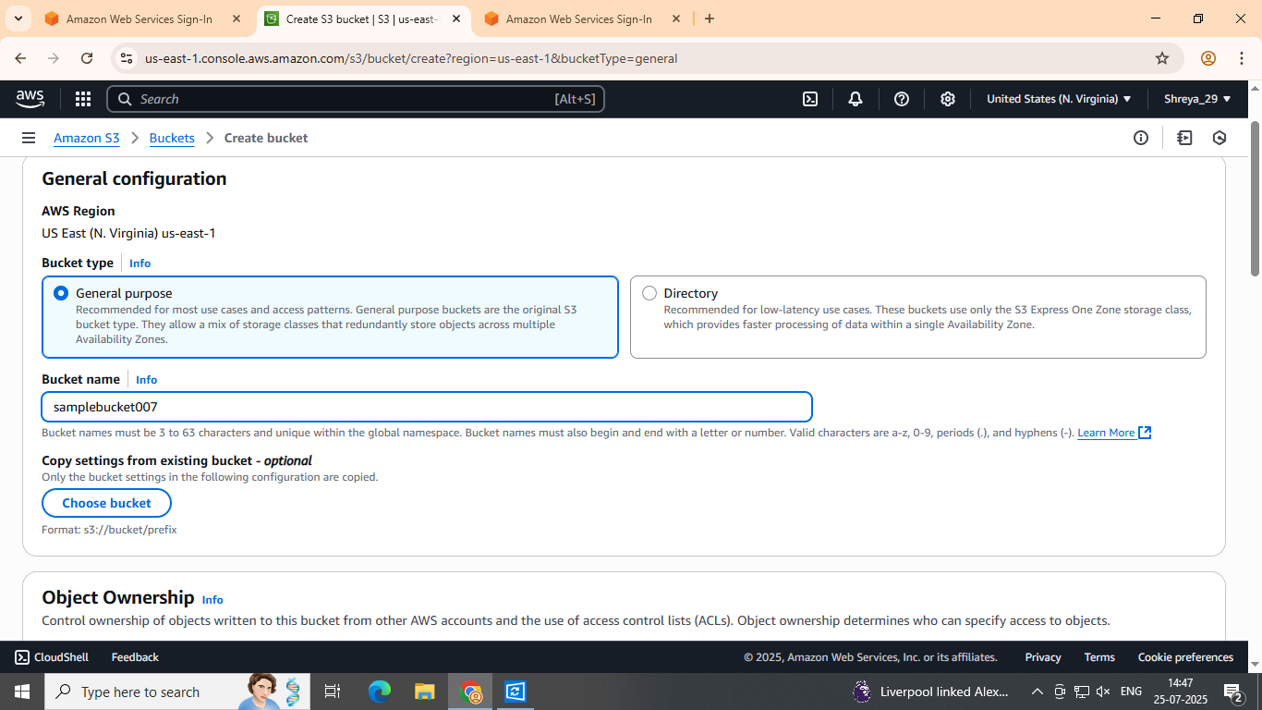Step 3: Enter a name for the bucket.

**Step 4:** Uncheck **"Block all public access"** and check the acknowledgment box to confirm your changes.

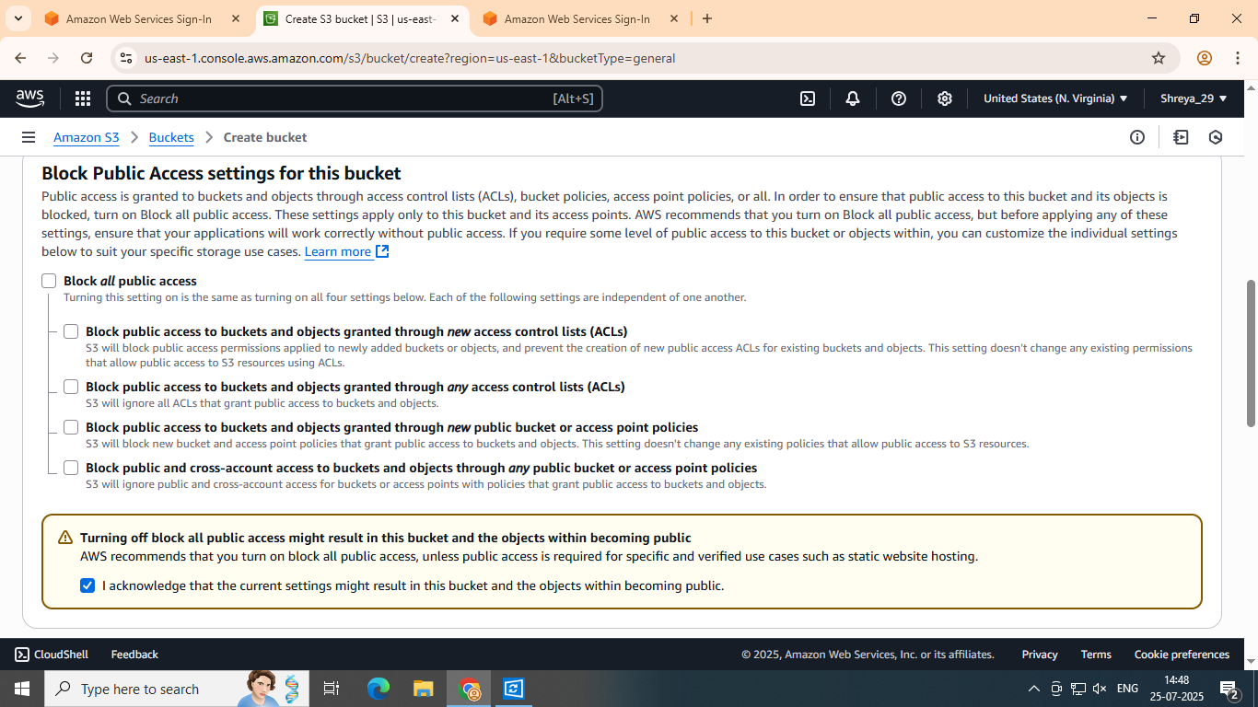

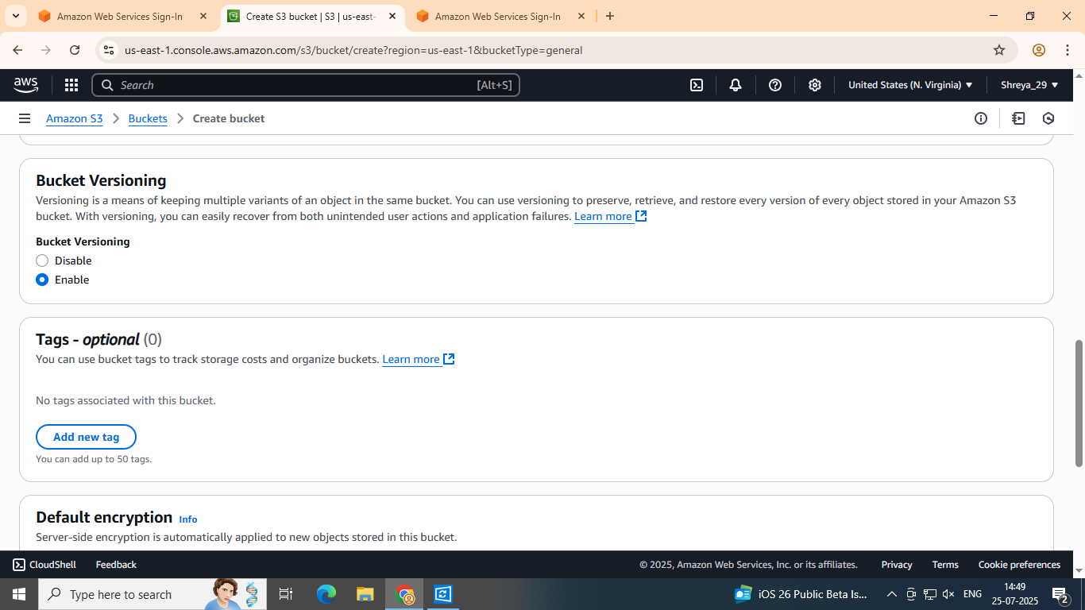Step 5: Click on "Enable" under Bucket Versioning.

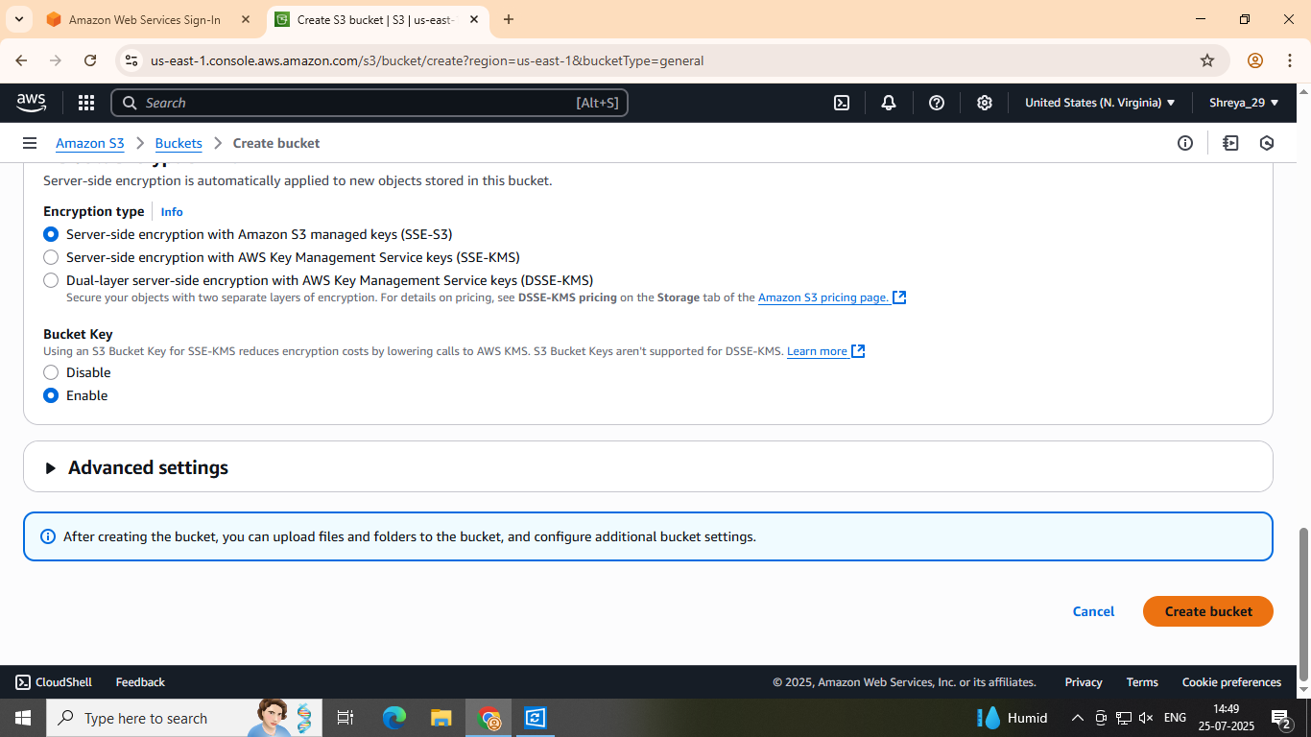 Step 6: Click on "Create bucket".

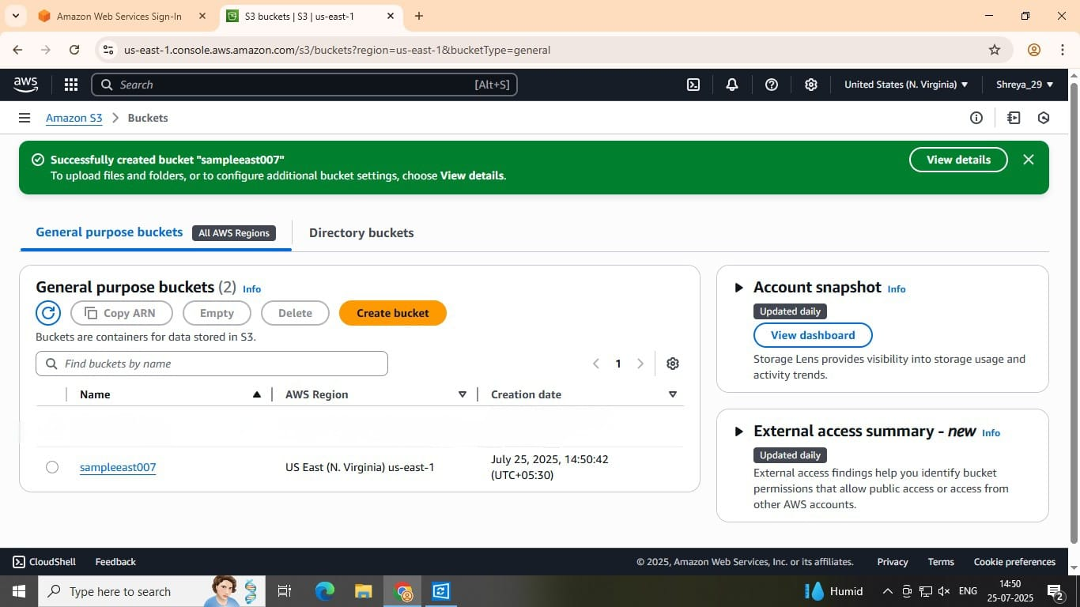Step 7: A confirmation message will appear indicating that the bucket has been successfully created with your specified bucket name. Sr

Step 8: Click on the bucket you created and navigate to the "Permissions" tab.

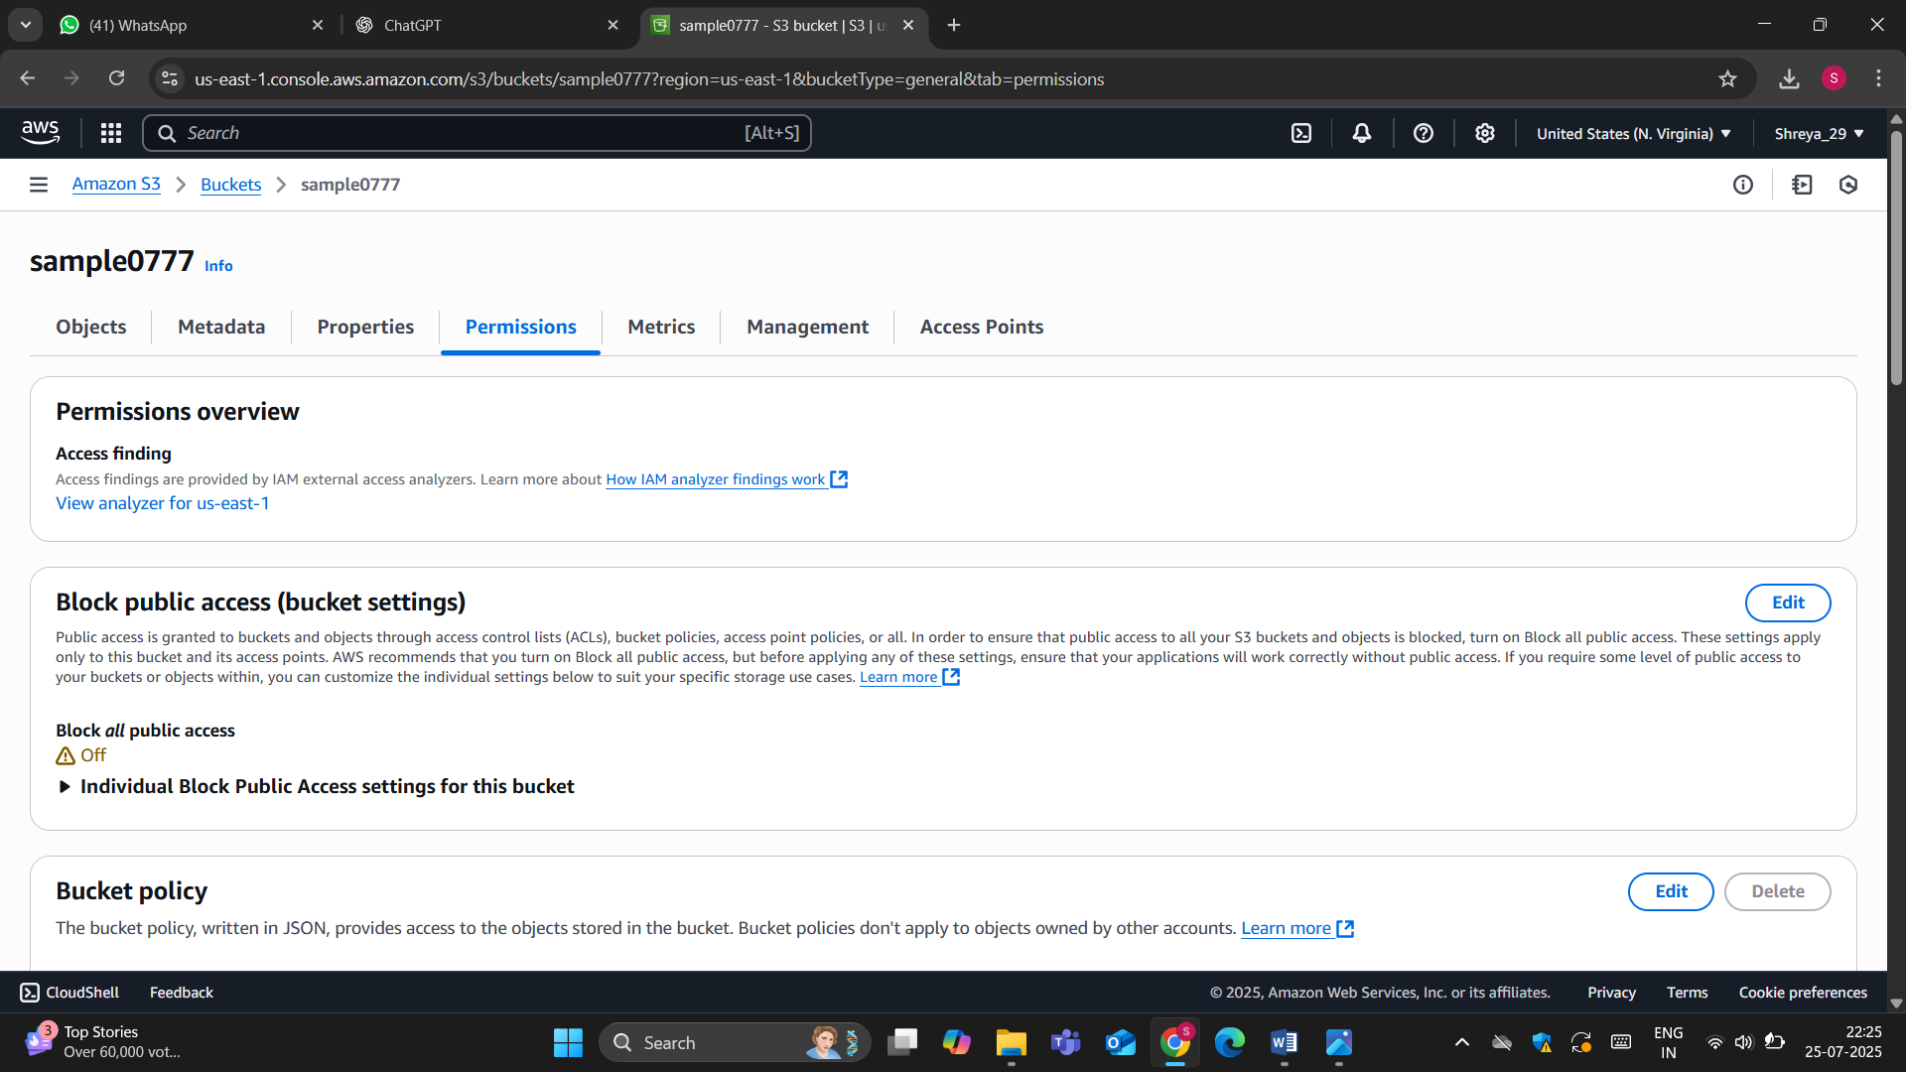

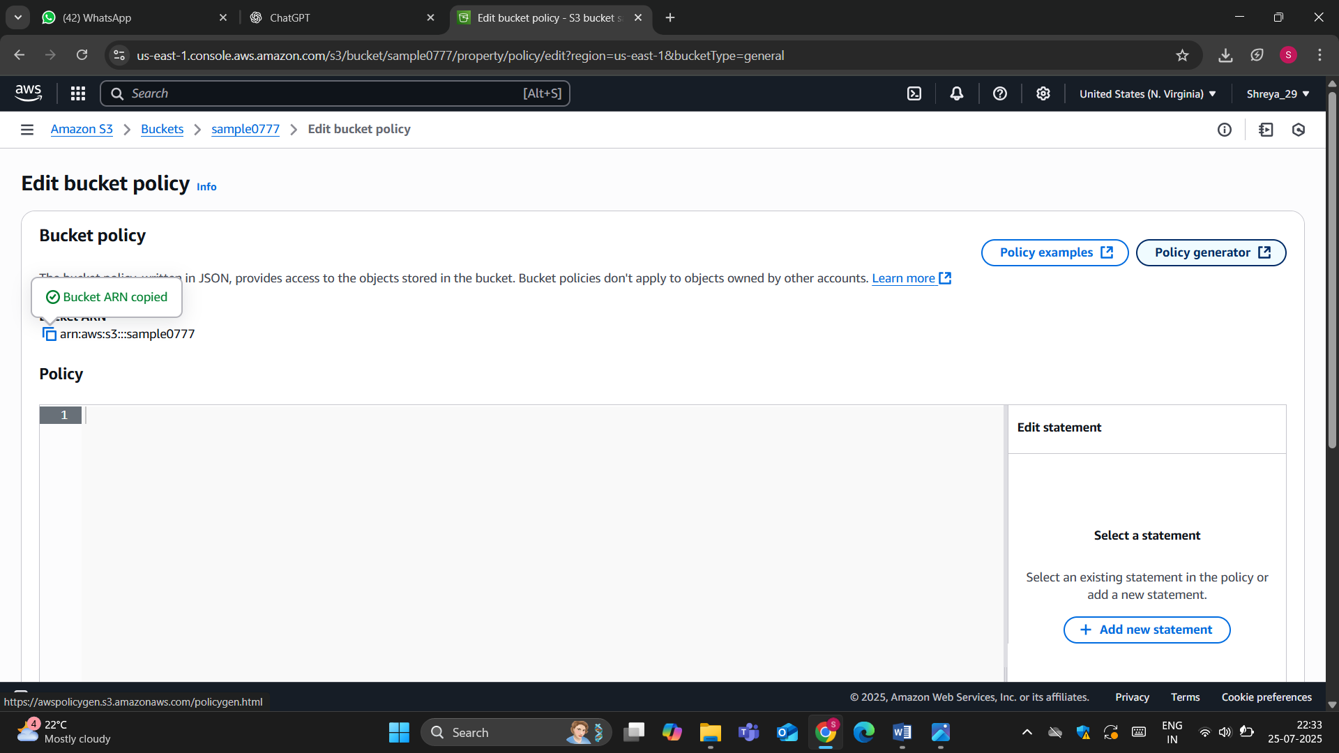Step 9: Scroll down to the "Bucket policy" section, click "Edit", copy the bucket ARN, and then click on "Policy Generator".

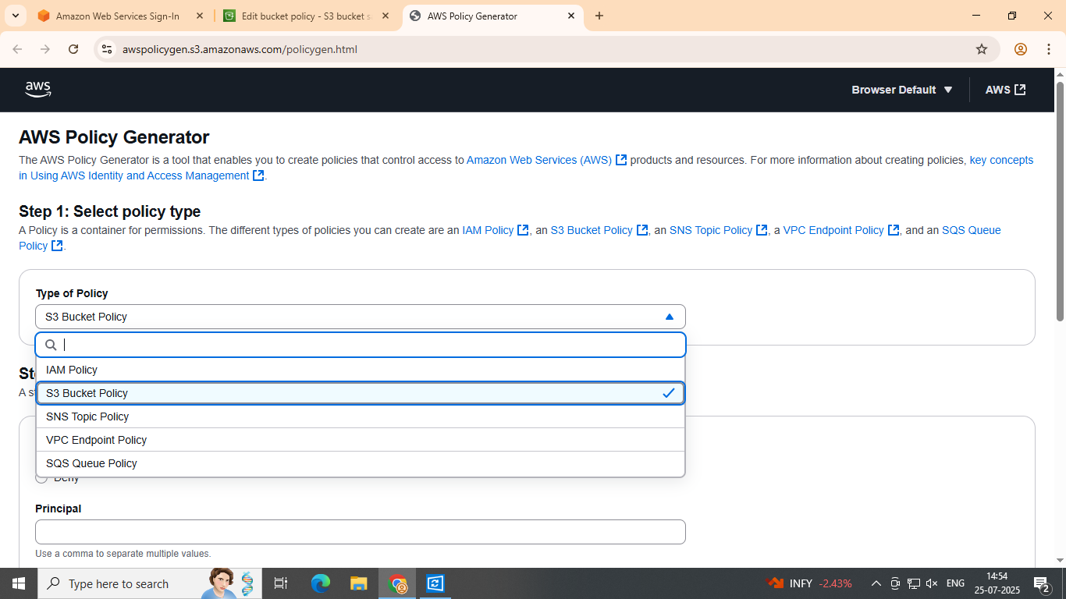 **Step 10: In the Policy Generator, select the policy type as "S3 Bucket Policy".**

**Step 11:** In **Principal**, type *.In **Actions**, select **‘GetObject’**.  
In **Amazon Resource Name (ARN)**, paste the ARN you copied in the previous step.  
Then click **"Add Statement"**, and finally click **"Generate Policy"**

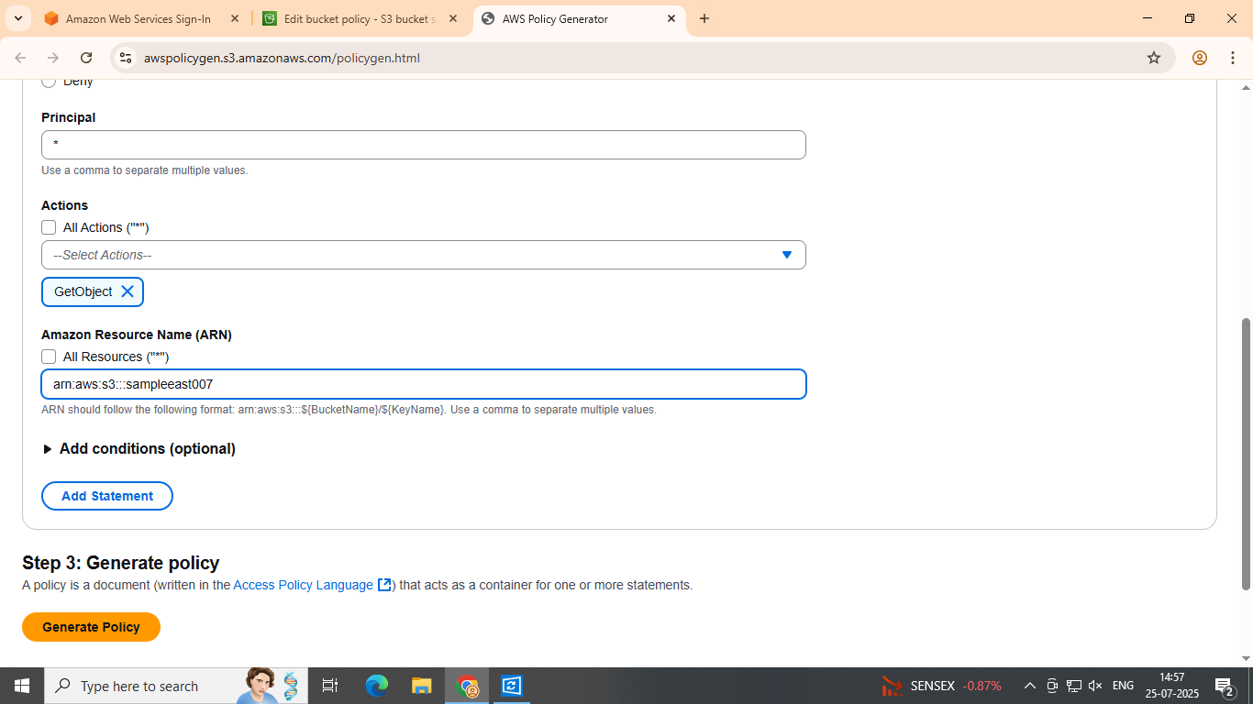

**Step 12:** The policy will be generated. Copy the policy and paste it into the S3 bucket policy. At the end of the ARN, add /* to include all objects within the bucket and click on Save Changes.

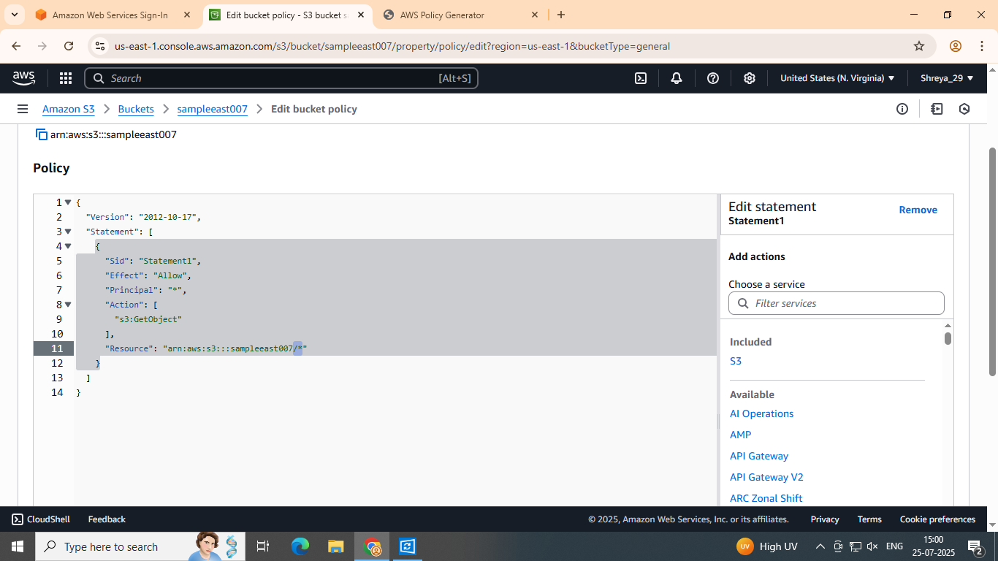

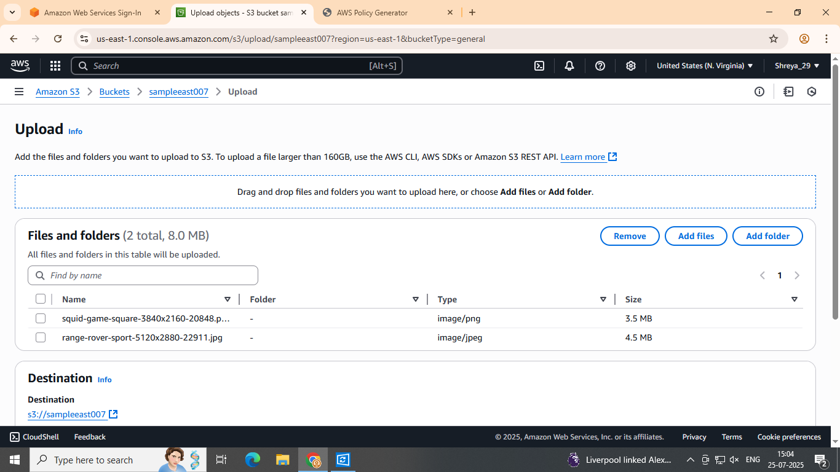Step 13: Navigate to your bucket, click on it, then click "Upload". Select the file you want to upload. Once uploaded, the files will be displayed, as shown in the figure.

Step 14: After the file has been successfully uploaded, click on the file and copy the Object URL.

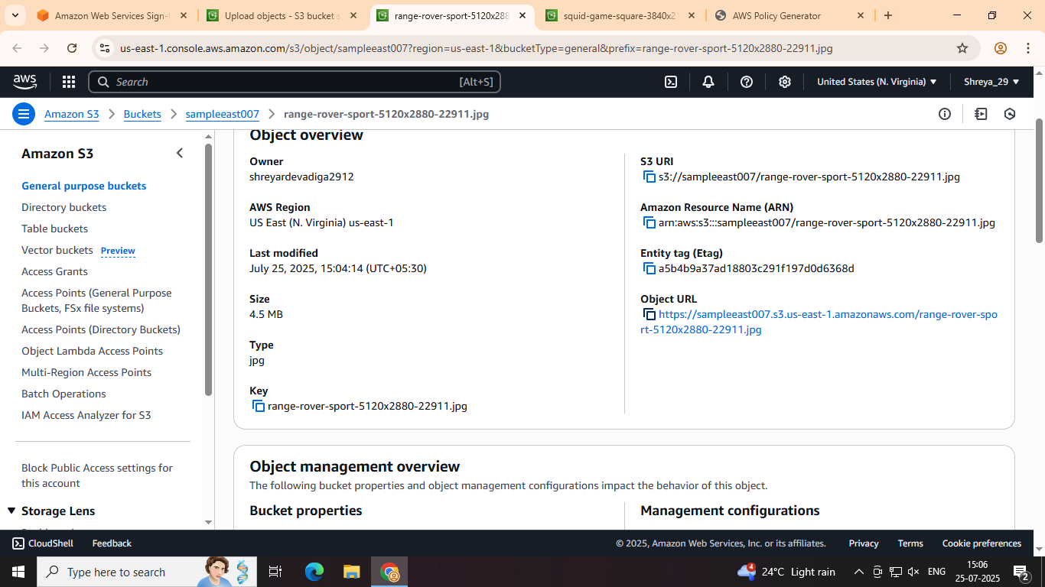

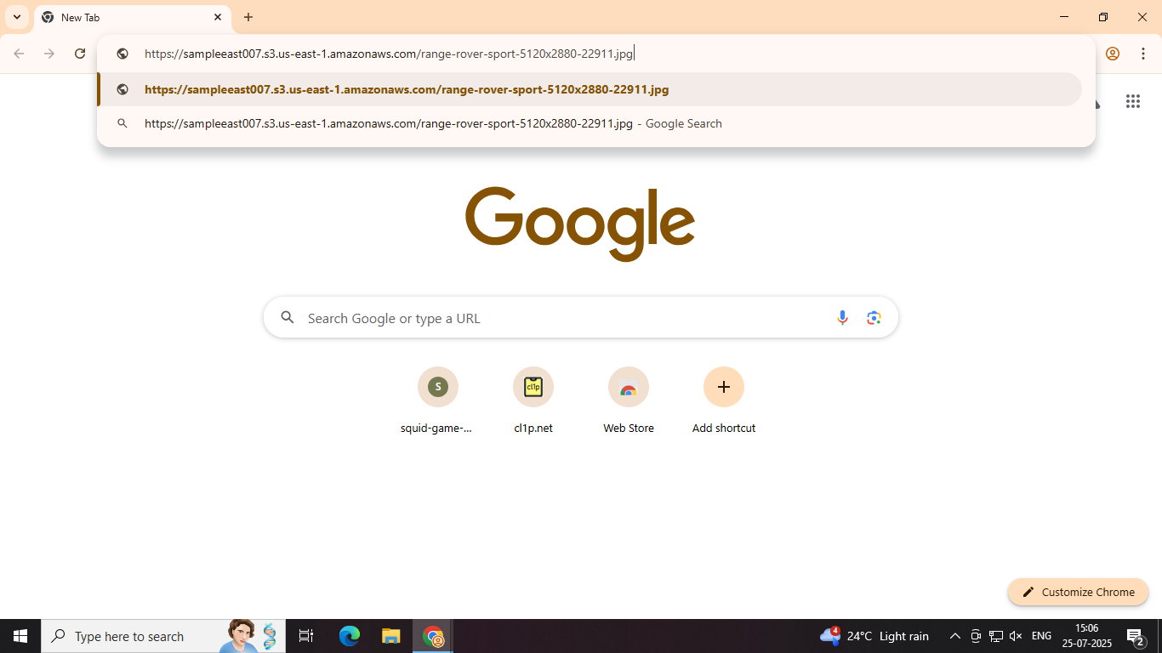Step 15: Paste the copied URL into your browser, and you will be able to access the file you uploaded.